**Lab 1 — Graphic Tools**

1. **Pie Chart**

Data: ex3-1.mtw



1. **Bar Graph and Bar Graph - Percentages**

Data: ex3-1.mtw

This bar graph shows each program (x-axis) and the total expenditures (y-axis).



Data: ex3-1.mtw

This bar graph shows each program (x-axis) and the total expenditures as percentage (y-axis).



1. **Time Series Plot:**

Data: ex3-2.mtw  
This time series graph for passenger car and SUV/trucks. SUV/Truck have consistently increased from 1990 to 2002.



1. **Area Graph:**

Data: ex3-2.mtw  
This area graph for passenger car and SUV/trucks. The graph shows each year (x-axis) and the total number (y-axis) of SUV/Truck and passenger cars.



1. **Histogram – Frequency and Relative Frequency:**

Data: ex3-4.mtw  
This is frequency histogram for floride. 

1. **Dotplot:**

Data: ex3-4.mtw  
This is a dot plot for floride. 

1. **Stem-and-Leaf Plot:**

Data: ex3-4.mtw  
This is a stem and leaf plot for floride. 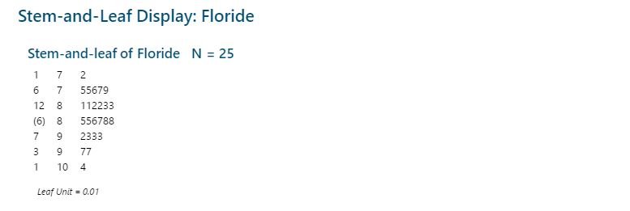

1. **Boxplot:**

Data: ex3-4.mtw  
This is a box plot for floride. There are no outliers.

1. **Bar Charts for Grouped Data:**

Data: ex3-18.mtw  
This is a bar plot for class. This bar graph shows each class (x-axis) and the frequency (y-axis).

